# **Student Task Manager App Report**

*Name:*

*Submitted to:*

*Technology used: Flutter*

*Link to app: https://github.com/harshit-456/Flutter-Mobile-App*

Contents

**Student Task Manager App Report** 1

**Summary:** 2

**Implemented Functionalities** 3

**1.** **Sign in:** 3

**2.** **Sign up** 4

**3.** **Dashboard** 5

**Additional Functionalities(Not Implemented)** 7

**1.** **Calendar View:** 7

**2.** **Task list** 8

**3.** **Notification Screen** 10

**4.** **Profile Setting** 11

# **Summary:**

The Student Task Manager is a dynamic mobile application designed to simplify and enhance the task management experience for students. Developed using the Flutter framework, this app provides a seamless and responsive user interface.

# **Implemented Functionalities**

1. **Sign In**

The purpose of the Sign In feature is to provide users with a simple and safe authentication procedure. The Student Task Manager logo and an engrossing background image greet users on an aesthetically pleasing login screen. The layout is responsive, easily adjusting to various screen sizes to improve the user experience.

In the designated TextField widgets, users are prompted to enter their credentials, which include a username and password. The "Sign In" text-filled ElevatedButton is where the authentication process begins. Users are redirected to the Dashboard screen after logging in successfully.

The implementation places a strong emphasis on having a simple, user-friendly design that makes accessing the task management dashboard effortless for users.

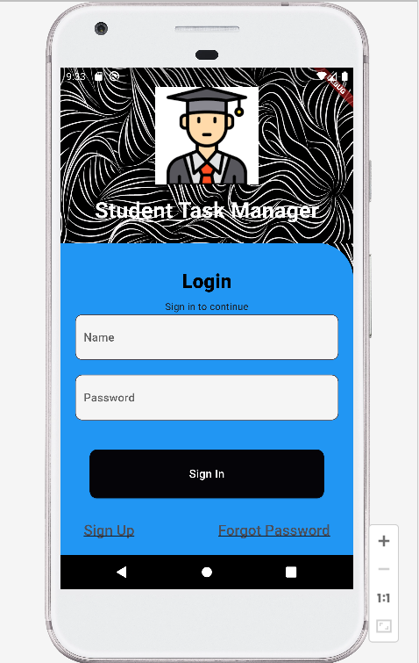 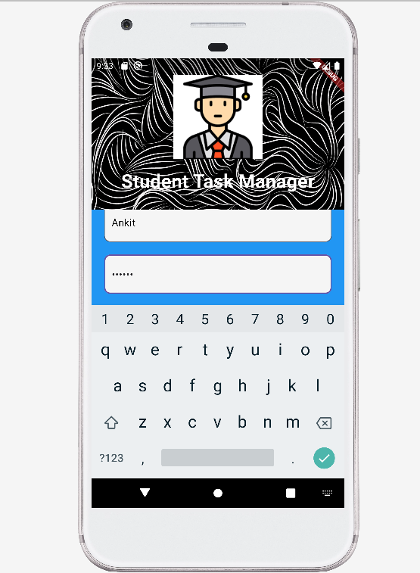

2. **Sign Up**

The Sign Up feature leads visitors through an easy-to-use registration process. Essential fields including name, email, password, and birthdate are found on the registration screen. An easy-to-use date picker is integrated into the date of birth field, providing a smooth and engaging method of entering this data.

The design clearly takes aesthetics into account, with a background image offering a visually pleasing background for the registration procedure. Users can easily move from the registration screen to the login screen thanks to the "Already registered? Sign in here" text button.

Overall, the Sign Up feature puts a high priority on usability and aesthetic appeal to make sure new users have a great onboarding experience.

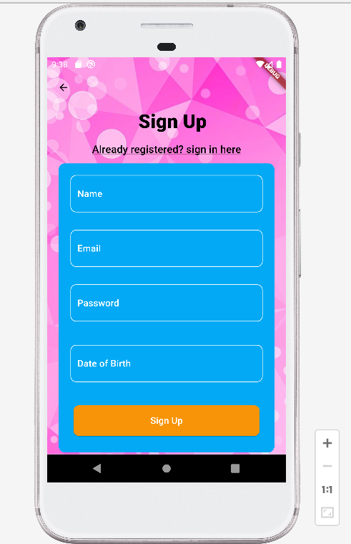

3. **Dashboard**

The focal point of the Student Task Manager app is its Dashboard feature. After successfully logging in, users are greeted with an interesting and educational dashboard. The "Upcoming Deadlines" section, the app title, and an image of the student are all included in the layout.

By encouraging users to explore the dashboard view, the call-to-action button promotes an active approach to task management. The button's design complements the app's overall aesthetic with its vivid colors and legible text.

Future iterations of the Dashboard will expand its capabilities, even though the current functionality prioritizes visual appeal and fundamental dashboard information. Future improvements will show an extensive list of all the assignments that need to be completed as well as more details about the user's academic schedule.

In summary, the Dashboard functionality aims to provide users with an aesthetically pleasing and informative hub for managing their academic responsibilities.

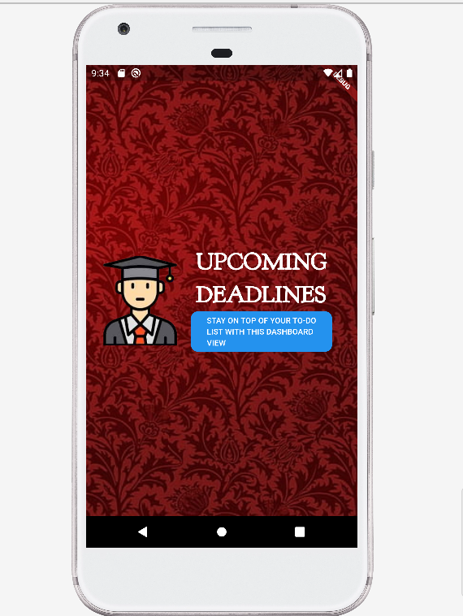

# **Additional Functionalities(Not Implemented)**

## **Calendar View:**

With a whole calendar displayed at the top and a special area for projects with deadlines below, the Calendar View offers a thorough approach to task management. To facilitate efficient long-term planning, the top section gives customers a visual picture of their entire month. Users may effortlessly switch between months using the interactive calendar, making it an easy-to-use tool. Below, users are presented with a curated list of tasks accompanied by their corresponding dates in the dedicated "Deadline Tasks" area.

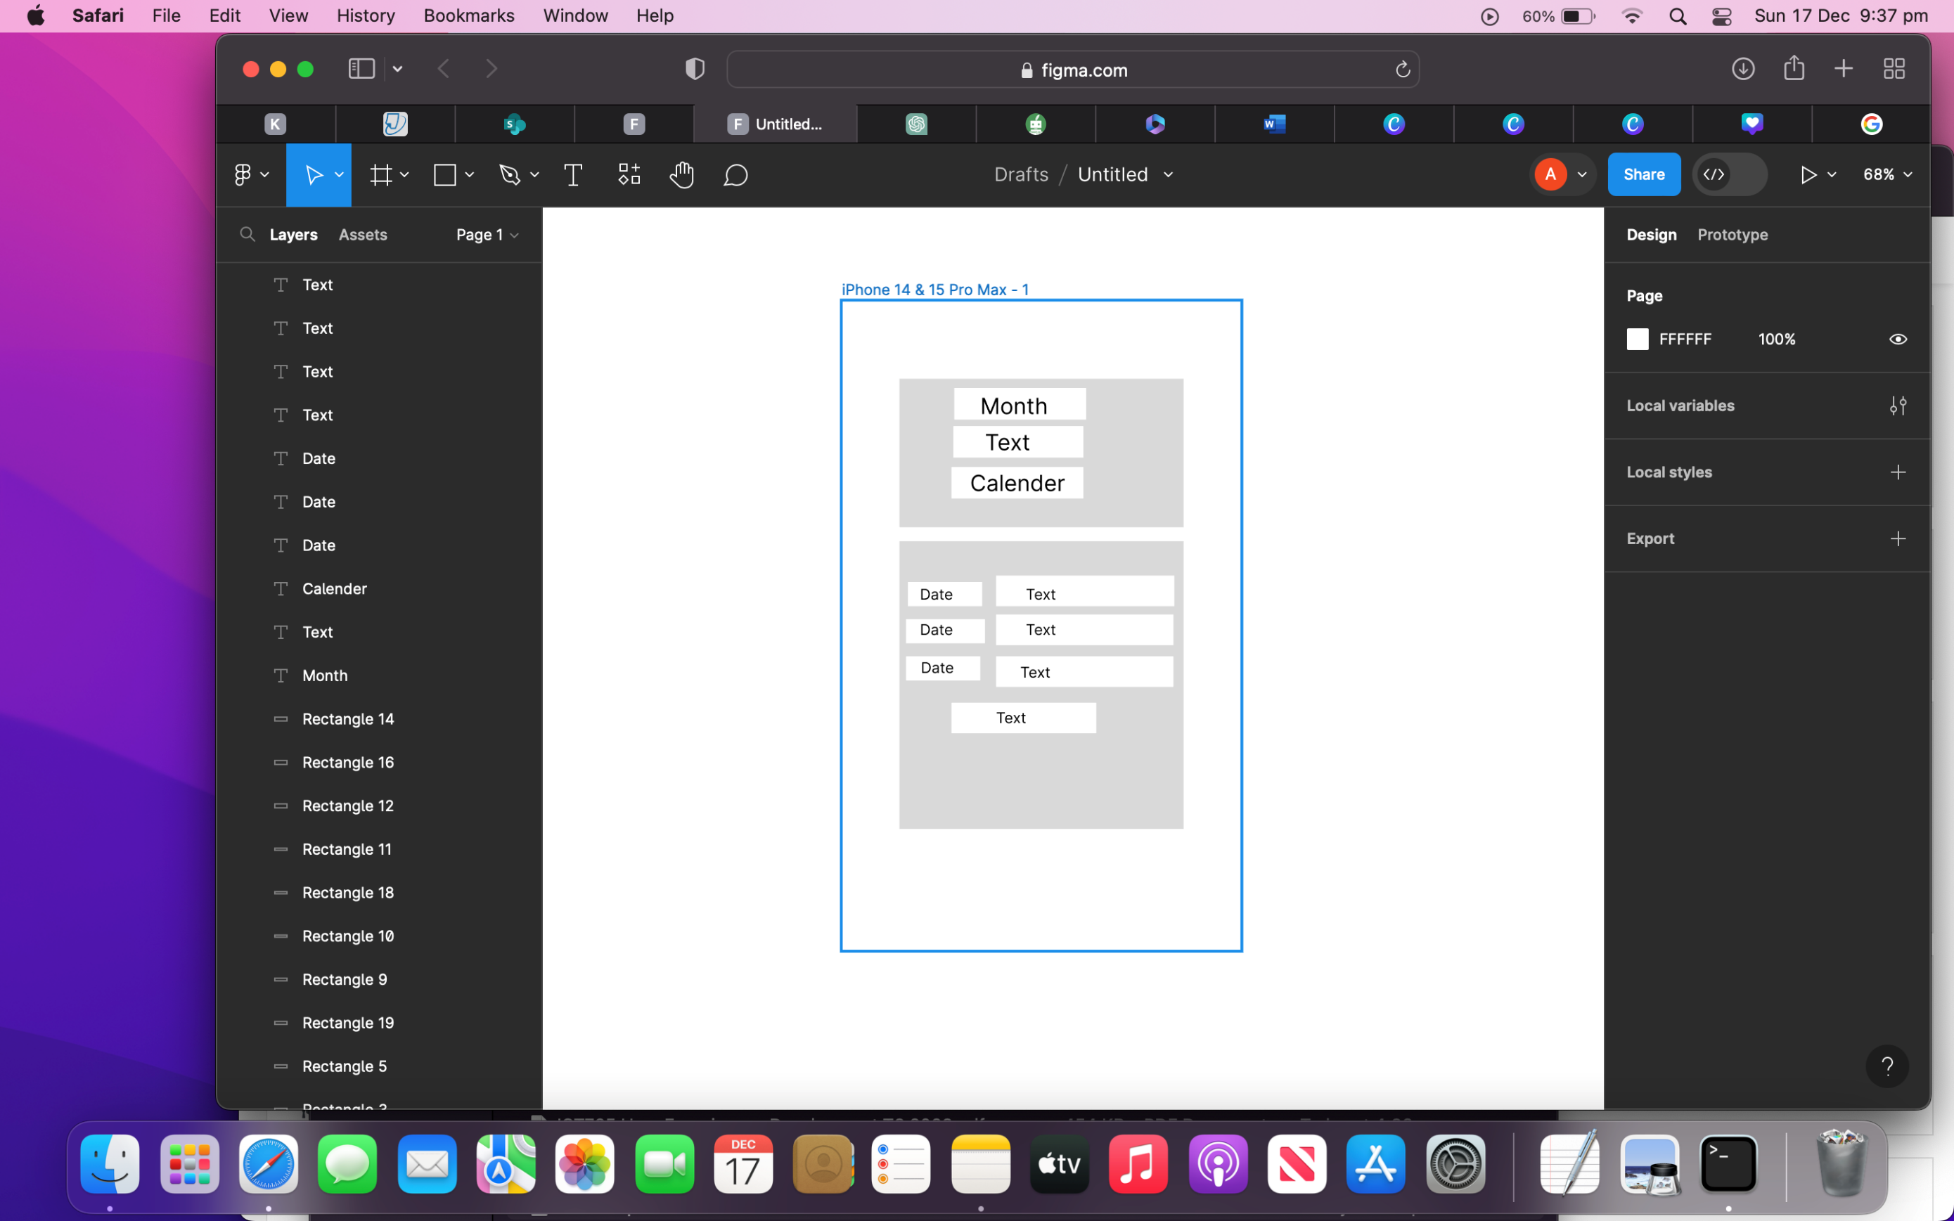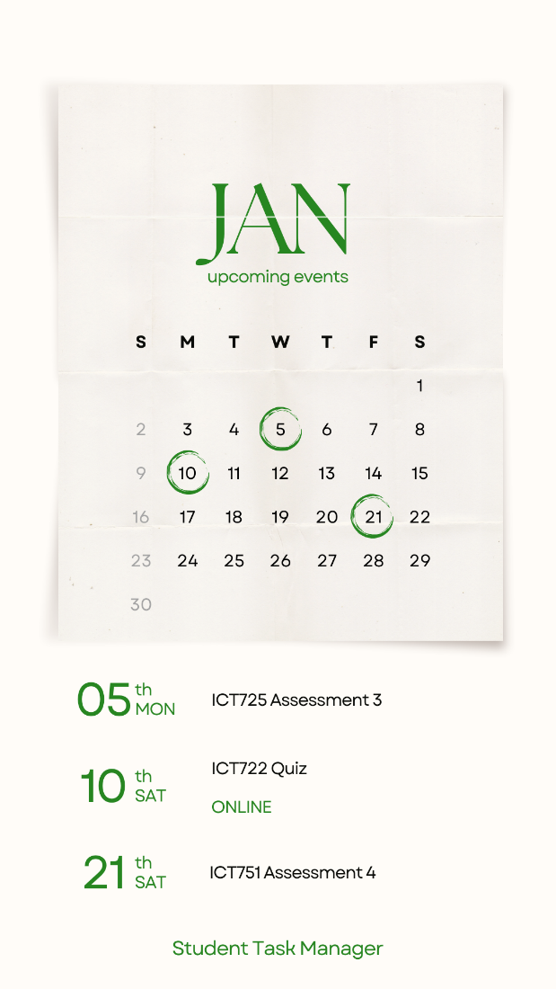

1. **Task list:**

Users can examine a clear, eye-catching summary of their work with the Task List Screen. With a task icon and the text "Tasks List" at the top, the screen is easier to navigate. Below that, a neatly arranged tasks list gives customers comprehensive details, facilitating a rapid comprehension of their upcoming tasks. The pagination icon at the bottom makes it easy to navigate through a long task list.

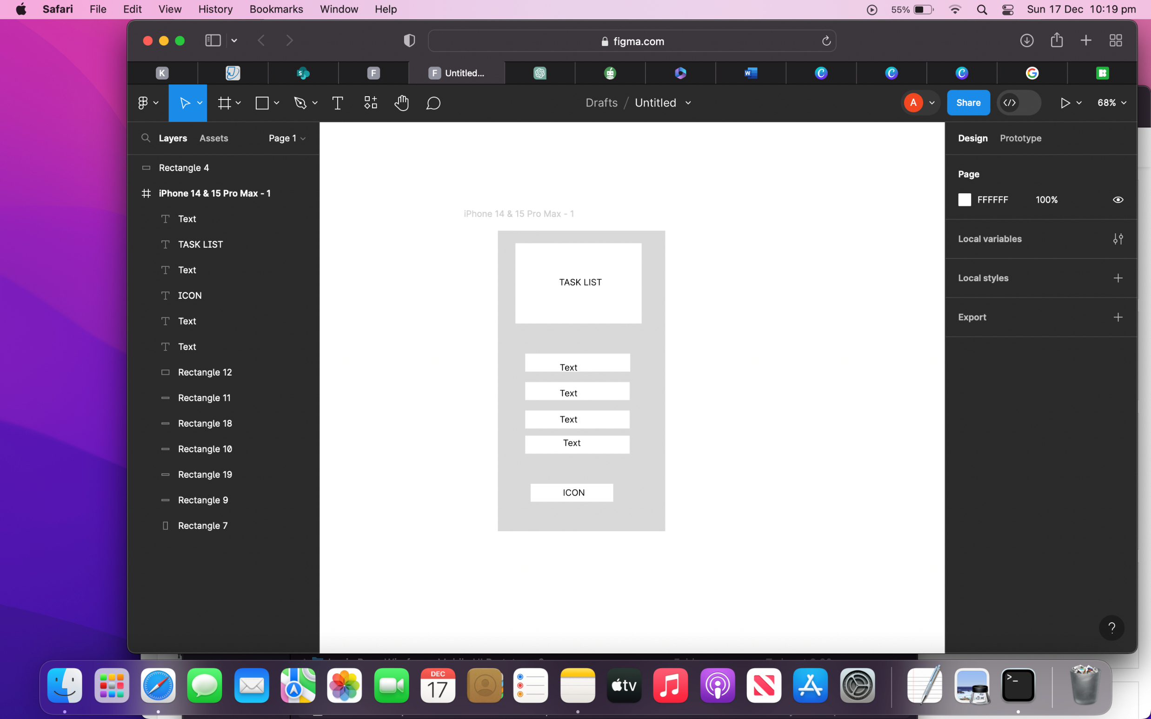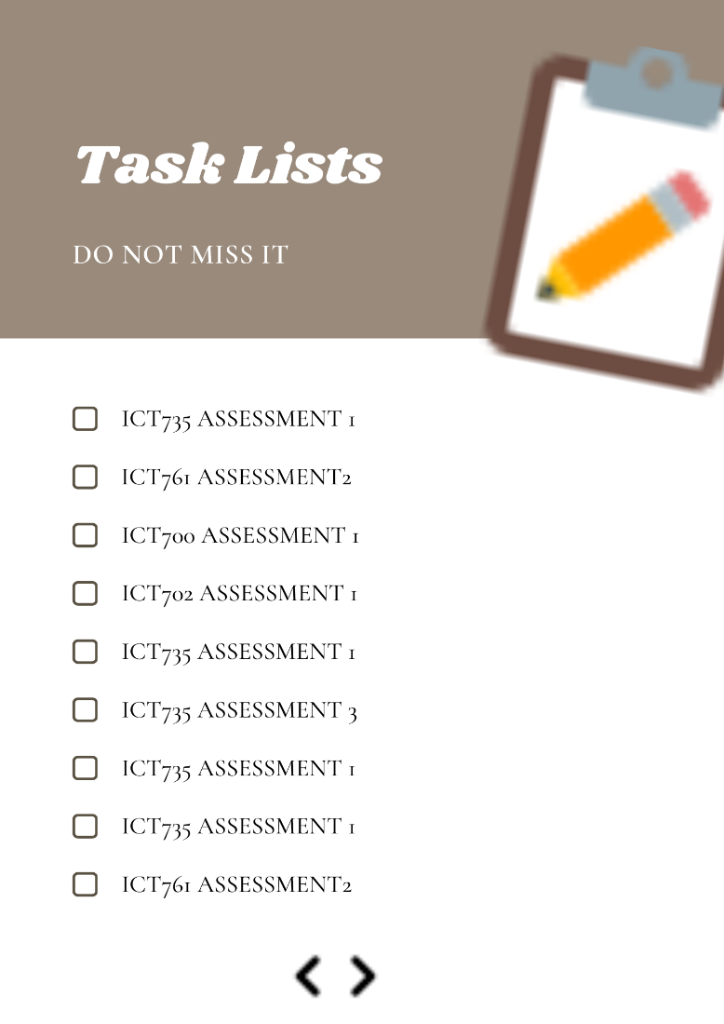

1. **Notification Screen:**

Bringing task notifications to users even when the device is locked is a critical function of the Notification Screen. Users will always be aware of impending chores thanks to this functionality. Users are given immediate context via the notification, which shows important details like the task name and date. Easy notification management and dismissal are made possible by the presence of a visible "cross" button.

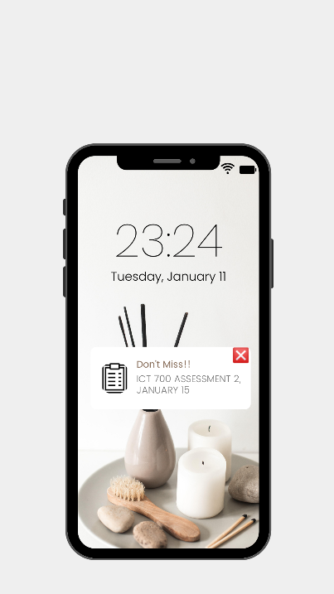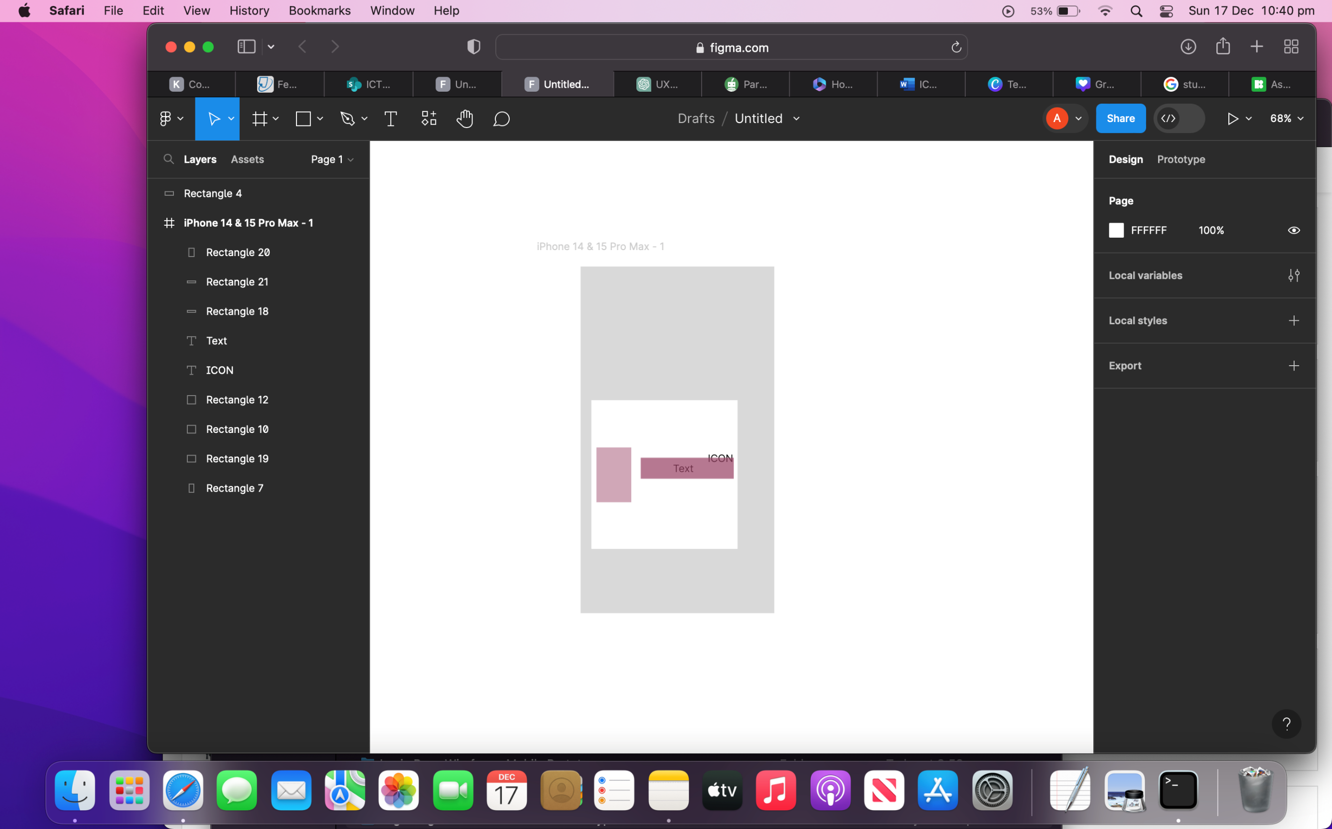

1. **Profile Setting:**

Thoughtfully split into two parts for easy browsing, the Profile Settings Screen provides a comprehensive hub for user control. By displaying the user's name, email address, and photo in the upper half, it creates a more individualized relationship with the user. Users can easily control their session with the strategically positioned "Log Out" button. Users may access essential features in the lower half of the screen by using icons for "Change Password," "About App," "Privacy Policy," "Terms and Conditions," and "Share This." Encapsulating a user-centric and transparent approach to user settings, its deliberate design prioritizes account administration and user personalization while providing quick access to crucial app-related information.

